1. **Open Microsoft project with the Homework project file**

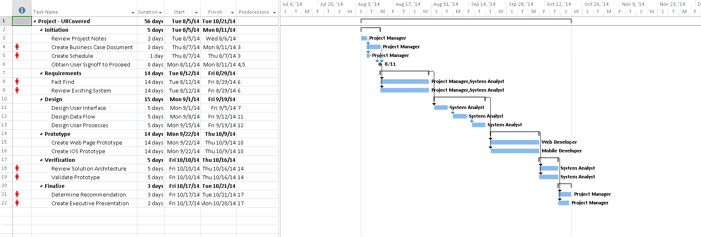

1. **Project views**
   1. **Usage** 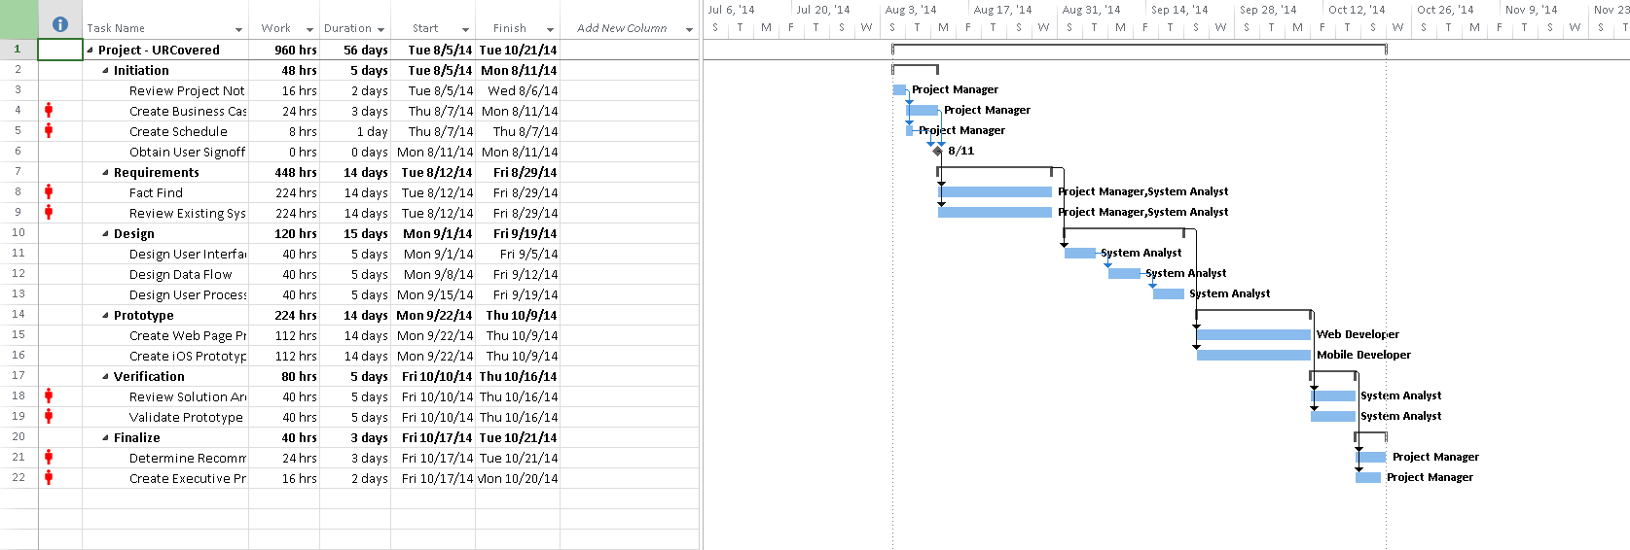
   2. **Network diagram**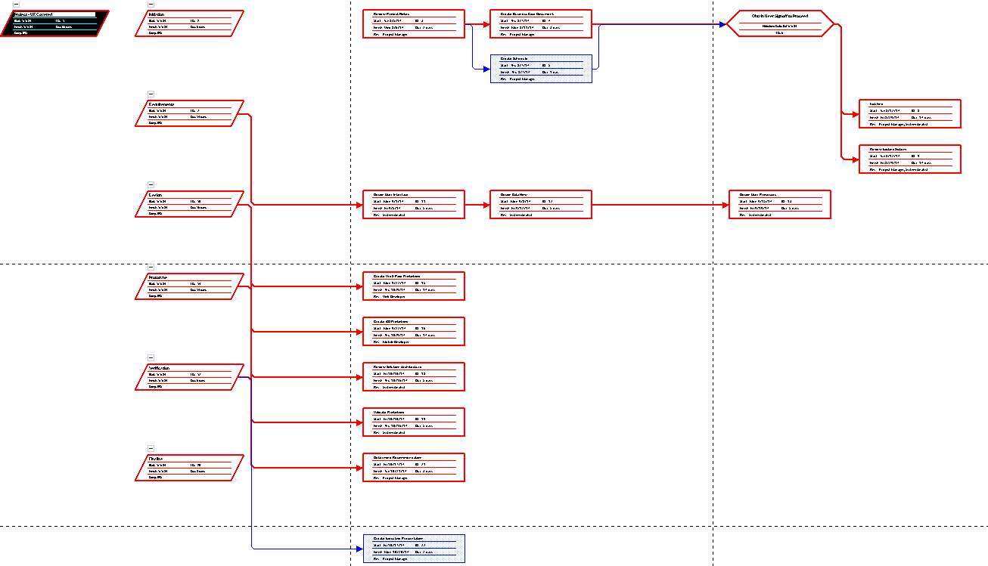
   3. **Resource sheet**
   4. **Resource usage**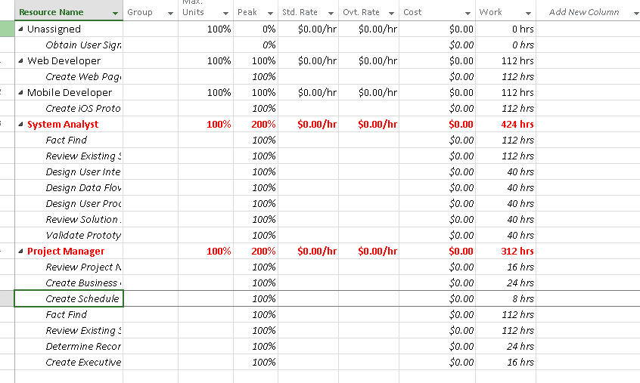
   5. **Task sheet**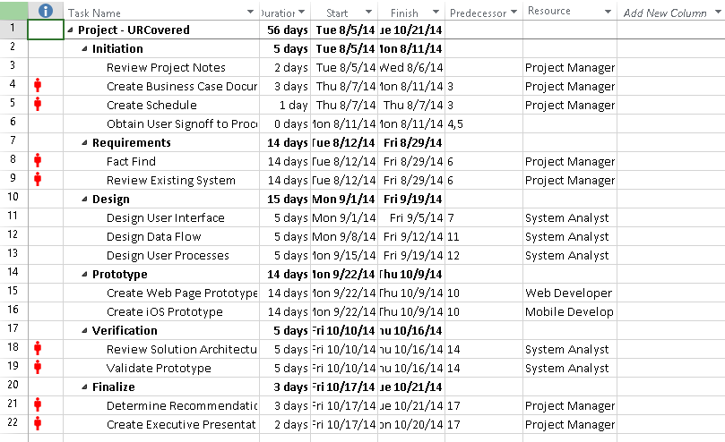
   6. **Timeline**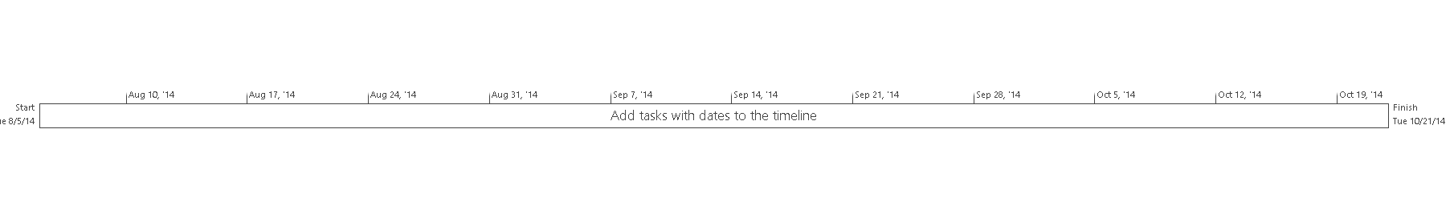
2. **Gantt Chart**
   1. **Auto scheduled** 
   2. **Change 14 day tasks to 10** 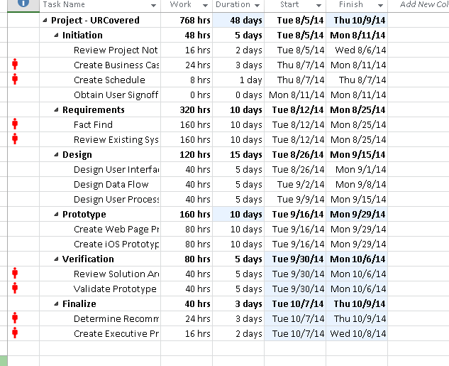
3. **Gantt chart resource Usage**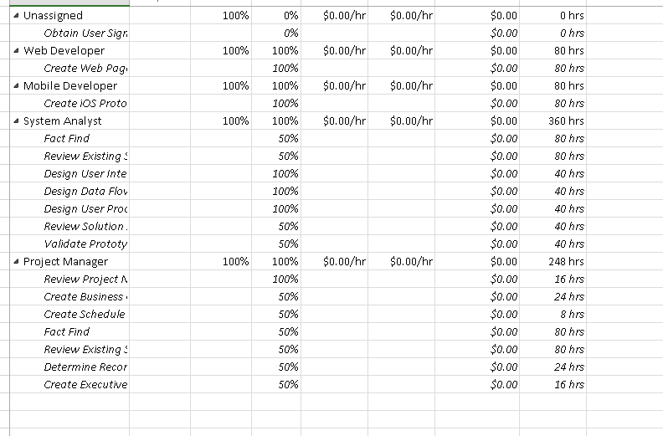
4. **Gantt chart tables usage**

# Resource assignments

1. Changing the resource unit from100% to 50% has changed the duration it takes to complete that task. The work required to complete the task has not changed. So the duration will shrink or grow as the resource unit allocation changes but the work hours will be static especially in IT projects.
2. **Resource sheet** 

# Project Cost

1. The total project cost is $36000.00. Changing the duration of the project should not have any changes to the total cost of the project as long as the resource allocation and the work remains the same. If the work changes and the allocation of the resource unit changes that will impact the total project cost.

Project statistics 